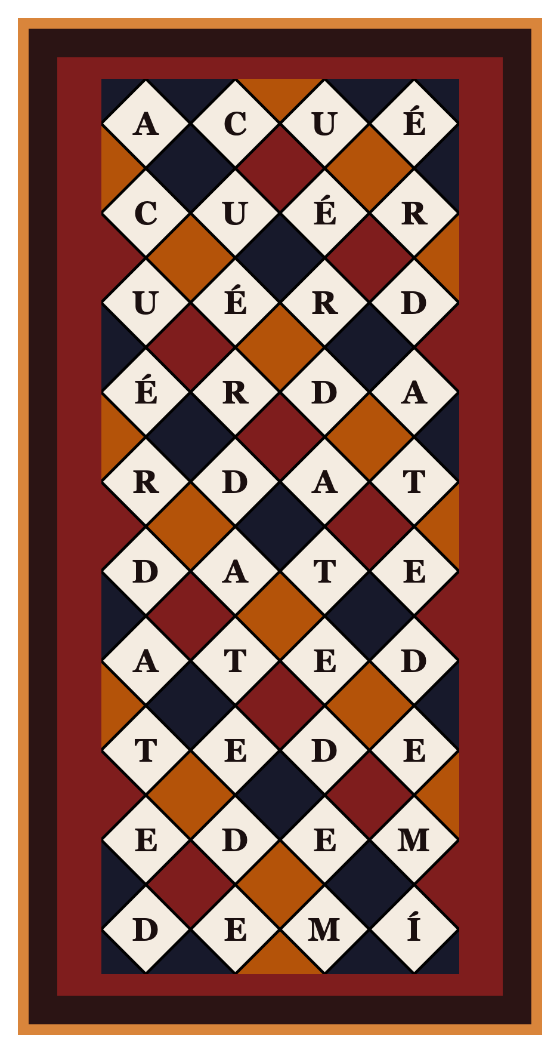 | - 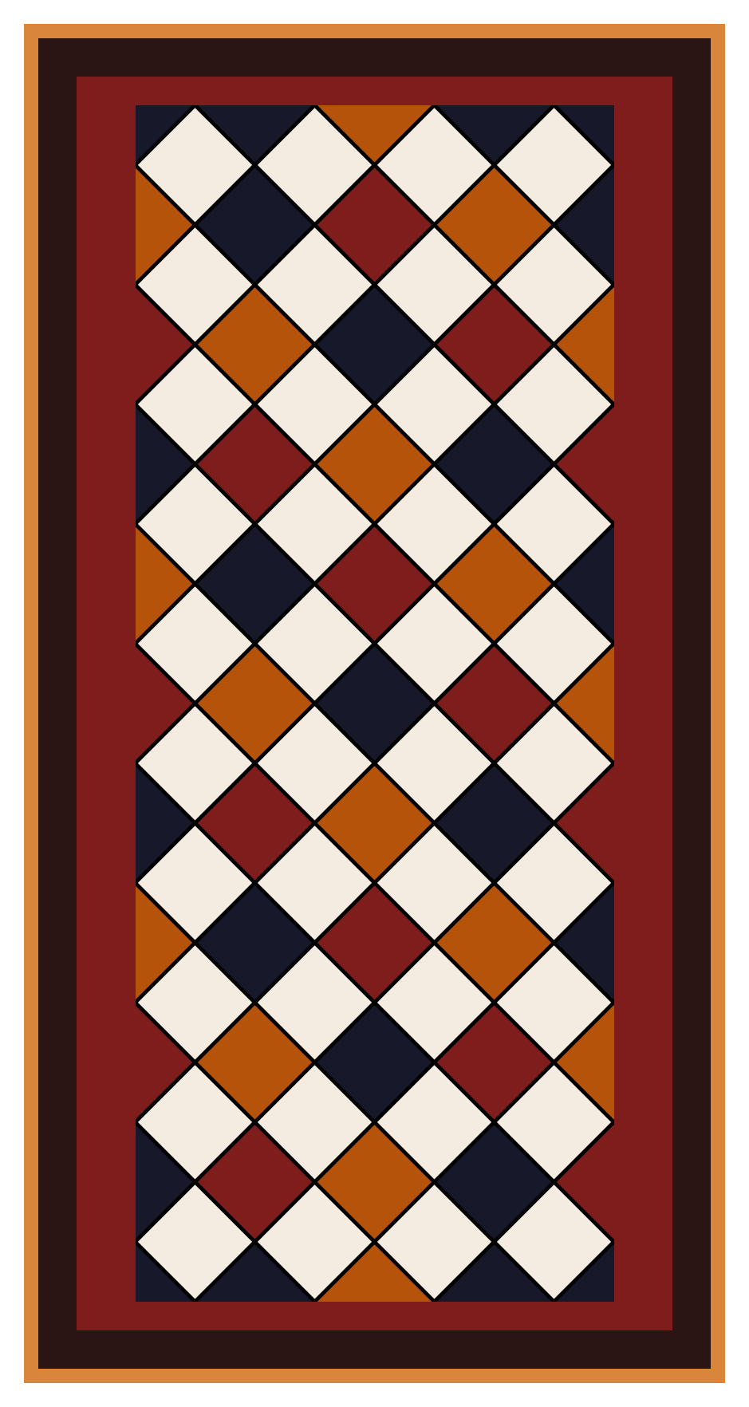
Recitation Labyrinth  This spiritual tool is built to help you recite a prayer or meditate on a thought.  The goal is to recite all of the possible ways to form a phrase, going from the First Square (Top-Left) to the Last Square (Bottom-Right).  1. Start at the First Square. This is now your current square.  2. Follow these instructions repeatedly:  From your current square, you will either have a choice of going down or right, or be on an edge, forced to go in one direction, or at the Last Square. Every time we have a choice, we will leave a token behind to remind us how to get back to the choice point.  Making a move  Case 1. If you have a choice (that is, you can go down or right):  - Place a token on the current square  - Move down  Case 2. If you are forced to move right (that is, you are on the bottom row),  - Move right  Case 3. If you are forced to move down (that is, you are on the right-most column),  - Move down  Case 4. If you are at the Last Square:  - Recite the prayer or intention  - Backtrack unless you are done  Case 2.1. If there are no tokens left on the card, you are done!  Case 2.1 Otherwise:  - Find the most recently placed token (this will be the token furthest down), and move to this square.  - Remove the token.  - Move Right.  REPEAT UNTIL YOU ARE DONE! | Recitation Labyrinth  This spiritual tool is built to help you recite a prayer or meditate on a thought  The goal is to recite all of the possible ways to form a phrase, going from the First Square (Top-Left) to the Last Square (Bottom-Right).  1. Start at the First Square. This is now your current square.  2. Follow these instructions repeatedly:  From your current square, you will either have a choice of going down or right, or be on an edge, forced to go in one direction, or at the Last Square. Every time we have a choice, we will leave a token behind to remind us how to get back to the choice point.  Making a move  Case 1. If you have a choice (that is, you can go down or right):  1. Place a token on the current square  2. Move down  Case 2. If you are forced to move right (that is, you are on the bottom row),  - Move right  Case 3. If you are forced to move down (that is, you are on the right-most column),  - Move down  Case 4. If you are at the Last Square:  - Recite the prayer or intention  - Backtrack unless you are done  Case 2.1. If there are no tokens left on the card, you are done!  Case 2.1 Otherwise:  - Find the most recently placed token (this will be the token furthest down), and move to this square.  - Remove the token.  - Move Right.  REPEAT UNTIL YOU ARE DONE!

